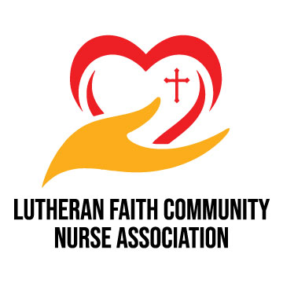

“We seek to be the light of Christ as we integrate faith and health in the ministry of parish nursing.”

Lutheran Faith Community Nurse Association Grant Application
The Grant is to be used for the development of a parish/faith community nurse ministry or to initiate an expanded or new focus of ministry
in a faith community

All applications must be received via email by March 15, 2023. Those awarded grant money will be asked to complete a written report one year after receiving the grant.

Criteria for eligibility:
- Must be a Lutheran faith community.
- The Faith Community must have an established health cabinet/wellness council or established interest/commitment by a licensed registered nurse or pastor.

Expectation of Grant Recipient: A parish nurse will be selected within 12 months of receiving the award. Failure to accomplish this will result in repeal of the grant and we ask the funds be returned to LFCNA.

Name of Faith Community:_____________________________________________________
Name of Individual applying on behalf of the faith community:________________________
Applicant Email:______________________________ Applicant Phone:__________________
Applicant’s Signature: _______________________________________Date: _____________

Senior Pastor’s Name:___________________________________________________________
Address:_____________________________________________________________________
__________________________________________________________________________________
Phone Number:_____________________________________________________________________
Email:_____________________________________________________________________________
Date:______________________________________________________________________________

FUNDING AMOUNT REQUESTED:  □ $750.00  □ ______________(less than $750.00) | FUNDS WILL BE USED TO:  □ Start a FCN/PN program  □ New focus of an existing Parish Nurse Ministry  Provide the program’s name/location/date  _________________________________

LIST 1-2 PROJECT GOALS FOR YEAR ONE: | LIST 1-2 PROJECT GOALS FOR YEARS TWO-FIVE:
DESCRIBE YOUR FAITH COMMUNITY’S/CONGREGATION’S READINESS FOR THIS PROGRAM:

DESCRIBE THE SUPPORT OF OTHER PROGRAMS IN YOUR FAITH COMMUNITY/CONGREGATION FOR YOUR PROGRAM:

BUDGET: All programs attach an itemized one-year budget.

□ Part of funds to be used for FCN course
□ FCN funded in another way. Please specify:
WHAT ARE YOUR PLANS TO MAKE THIS MINISTRY SUSTAINABLE IN THE FUTURE (beyond this grant award):

PLEASE SUBMIT A LETTER OF SUPPORT FOR THE PARISH/ FAITH COMMUNITY NURSE PROGRAM FROM YOUR PASTOR OR BOARD CHAIR PERSON WITH THIS APPLICATION. SELECT ONE OR MORE QUESTIONS TO ADDRESS IN THE LETTER OF SUPPORT.
- How does your congregation view the integration of faith and health?
- Describe a successful parish nurse ministry in your faith community. What would the main focus of the ministry be?
- If you have a parish nurse currently in place, how has this ministry been supported and received by the congregation?

Signature (electronic is acceptable)___________________________________________________
Date ___________________________

Please submit grant application via email to: hmbwiegert@gmail.com

